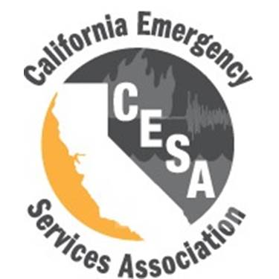
CESA State Board
State Board Policies Table of Contents | TOC updated  September 24, 2024
Policy Name | Approval/ Last Revision Date
Action Without Meeting | February 26, 2021
Association Board – Board Member Attendance Policy & Procedure
Attendance at Regular Association Board Meetings Via Electronic Means | Discontinued 10/2021
Awards | December 4, 2023
Campaigning Policy | December 4, 2023
CESA Official Response to Support/Not-Support Actions, Campaign Items, Initiatives Legislative Items | August 3, 2017
Committee Roles and Responsibilities | June 28, 2024
Conference and Training | September 22, 2023
Expectations and Duties of the Association Board Members | June 28, 2024
Finance Policy | January 2024
Legislative Platform | January 23, 2017
Member-At-Large | June 28, 2024
Membership Classification and Dues | August 23, 2024
Notifications to Membership of a Member’s Death | June 28, 2024
Officer Transition | January 23, 2017
Officers of the Association Board | September 22, 2023
Social Media | August 3, 2017
Special Emergency Telephonic/Electronic Board Meeting | January 23, 2017
Travel Reimbursements | June 28, 2024

